TECHNICAL RIDER (11 pages)

Show Reflections

Company Adi Boutrous

**CONTACTS**

Technical director - Asaf Ashkenazy

[aashkenazy@adiboutrous.com](mailto:aashkenazy@adiboutrous.com)

+972 545893577

Light designer - Ofer Laufer

[olaufer@adiboutrous.com](mailto:olaufer@adiboutrous.com)

+972 505909836

Contact production France : DdD

Eulalie Fages - [eulalie@dddames.com](mailto:eulalie@dddames.com)

+33 1 53 61 16 76

Company manager - Naama Kutner

[nkutner@adiboutrous.com](mailto:nkutner@adiboutrous.com)

+972 523615764

Number of people on tour: 8 or 9

Choreographer, 4 dancers, technical director, light designer, show manager, administrator.

**Presenter's representative**

The Presenter must designate an English speaking technical director with decision-making authority, to be present, responsible to, and accessible for consultation with the company at all times during set-up, rehearsals, performances and strike.

**Venue Plans and photos**

The Presenter will provide theater plans in a scale of not less than 1:50 and should include:

1. Ground plan showing layout of performance area/stage, backstage areas, loading dock, audience seating plan and production booth.
2. Side section plan showing stage, line set schedule, audience rake, height of ceiling, FOH instruments and grid, masking and normal trim of on-stage electrics.
3. VWX/ DWG / DXF / PDF format file of the plans.
4. Photos of the venue, preferably in digital format clearly showing the stage, Front of house and the various lighting positions.

The quality of the material submitted is very important for prior planning, as it is the company's policy to create detailed plots adapted for the Presenter’s venue.

**Venue Availability**

Theater / performing space (including off stage areas, fly space, loading dock)

Shall be available, cleared of other equipment, for the sole use of the company for the period of setup, rehearsals, performances, and Dismantling.

All required in‐house and/or rental equipment shall be available and ready at the start of setup.

**Local Crew**

Set-up and strike:

1 sound technicians

3 lighting technicians

3-4 stagehands

**On every show’s time:**

1 light operator

1 sound operator

We ask for the same crew that did the rehearsals to be the operators in every show.

**\*It is important for us to maintain concentration for all in the working space, we kindly ask to be aware and keep the silence around the stage area while the company works on light cues and rehearsing on stage.**

In case of a full day of technical preparations

an optimal schedule for this day would be:

1. stage and light setup

2. Light focus

3. Sound check

4. Technical Rehearsal

5. Full run through

**technical schedule:**

1. stage and light setup ( 9:00 -13:00 )

2. break (13:00-14:00)

3. Light focus (14:00 - 16:30 )

4. Sound check ( 16:30 - 17:00 )

5. Technical Rehearsal ( 17:00 - 19:30 )

6. preparing for run through ( 19:30 - 20:00 )

7. Full run through (20:00 -21:00 )

**Stage**

Total set and performance area 12 meters wide by 10 meters deep.

Different stage sizes should be discussed with and approved by the company.

The stage floor must be a sprung or dance floor construction. The floor must be smooth, even and level without any holes or cracks. Wood over a concrete floor is not acceptable.

Black linoleum - (Marley / dance floor) should be provided by the presenter, and layed down to cover the entire performance area.

The presenter will provide the necessary same colored black tape for

setting up the floor and will make sure that the stage deck is prepared for laying

down of Marley. The marley must be laid down and stretched properly so it would be straight without any folds .

**Grave (solid wood) :**

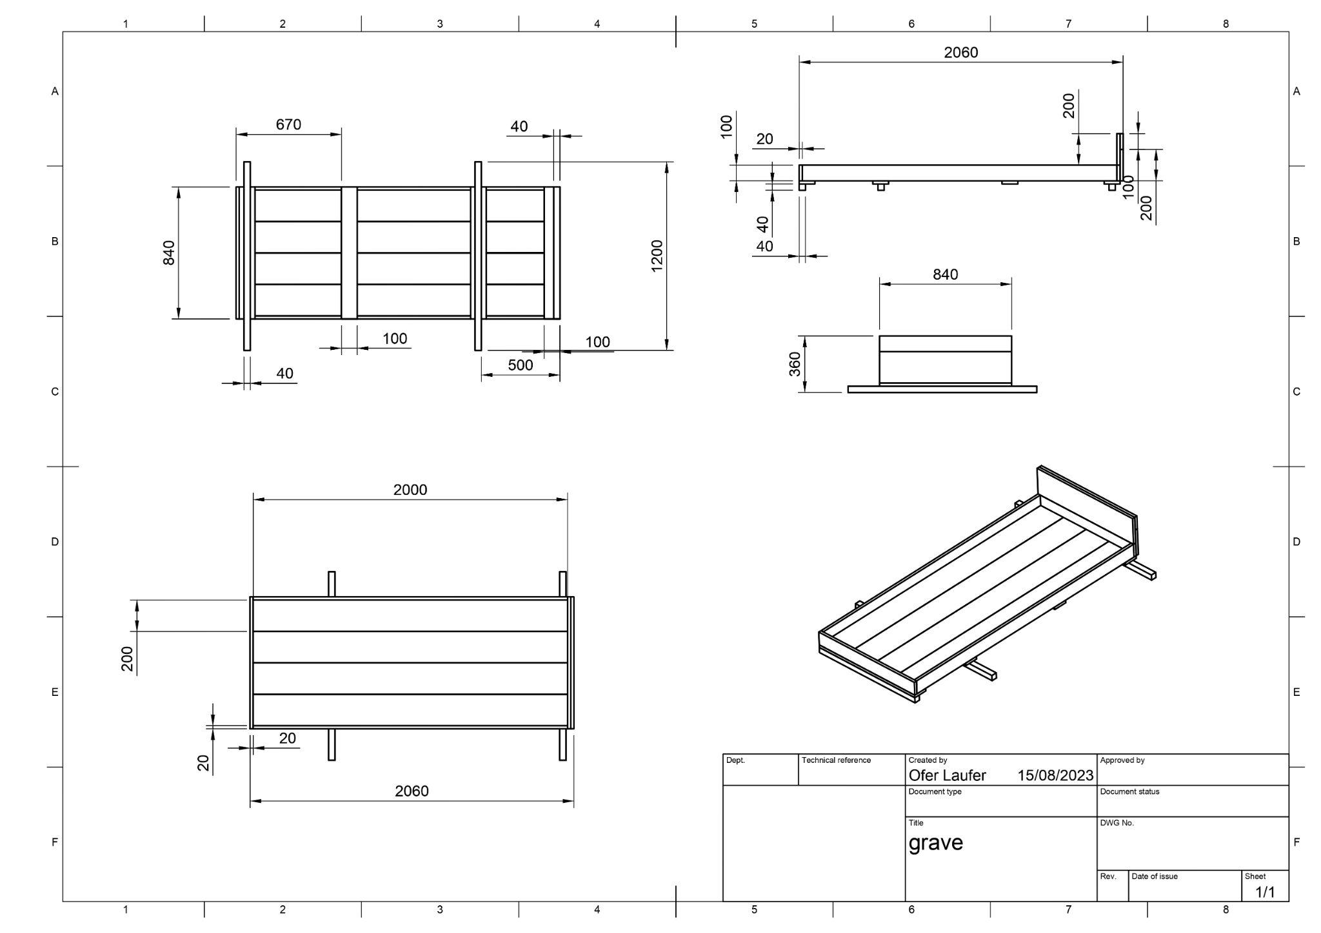

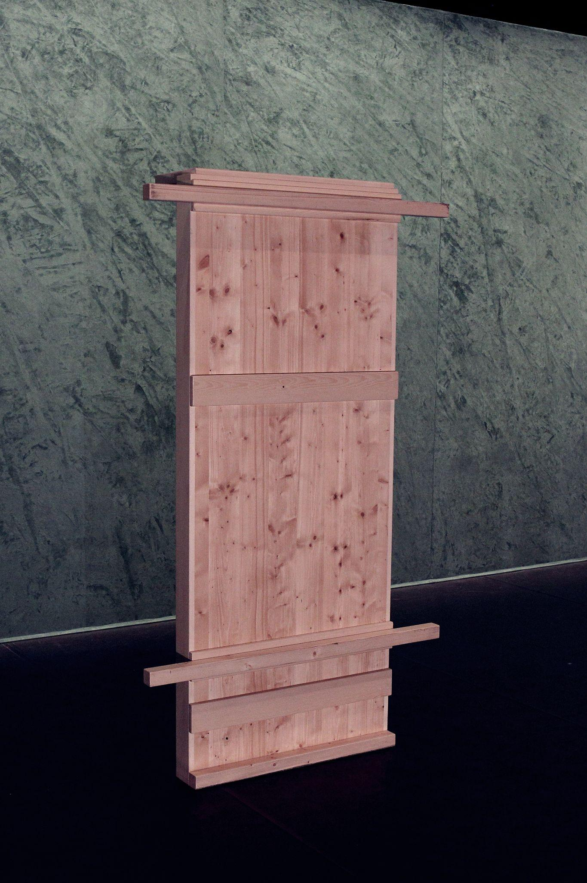

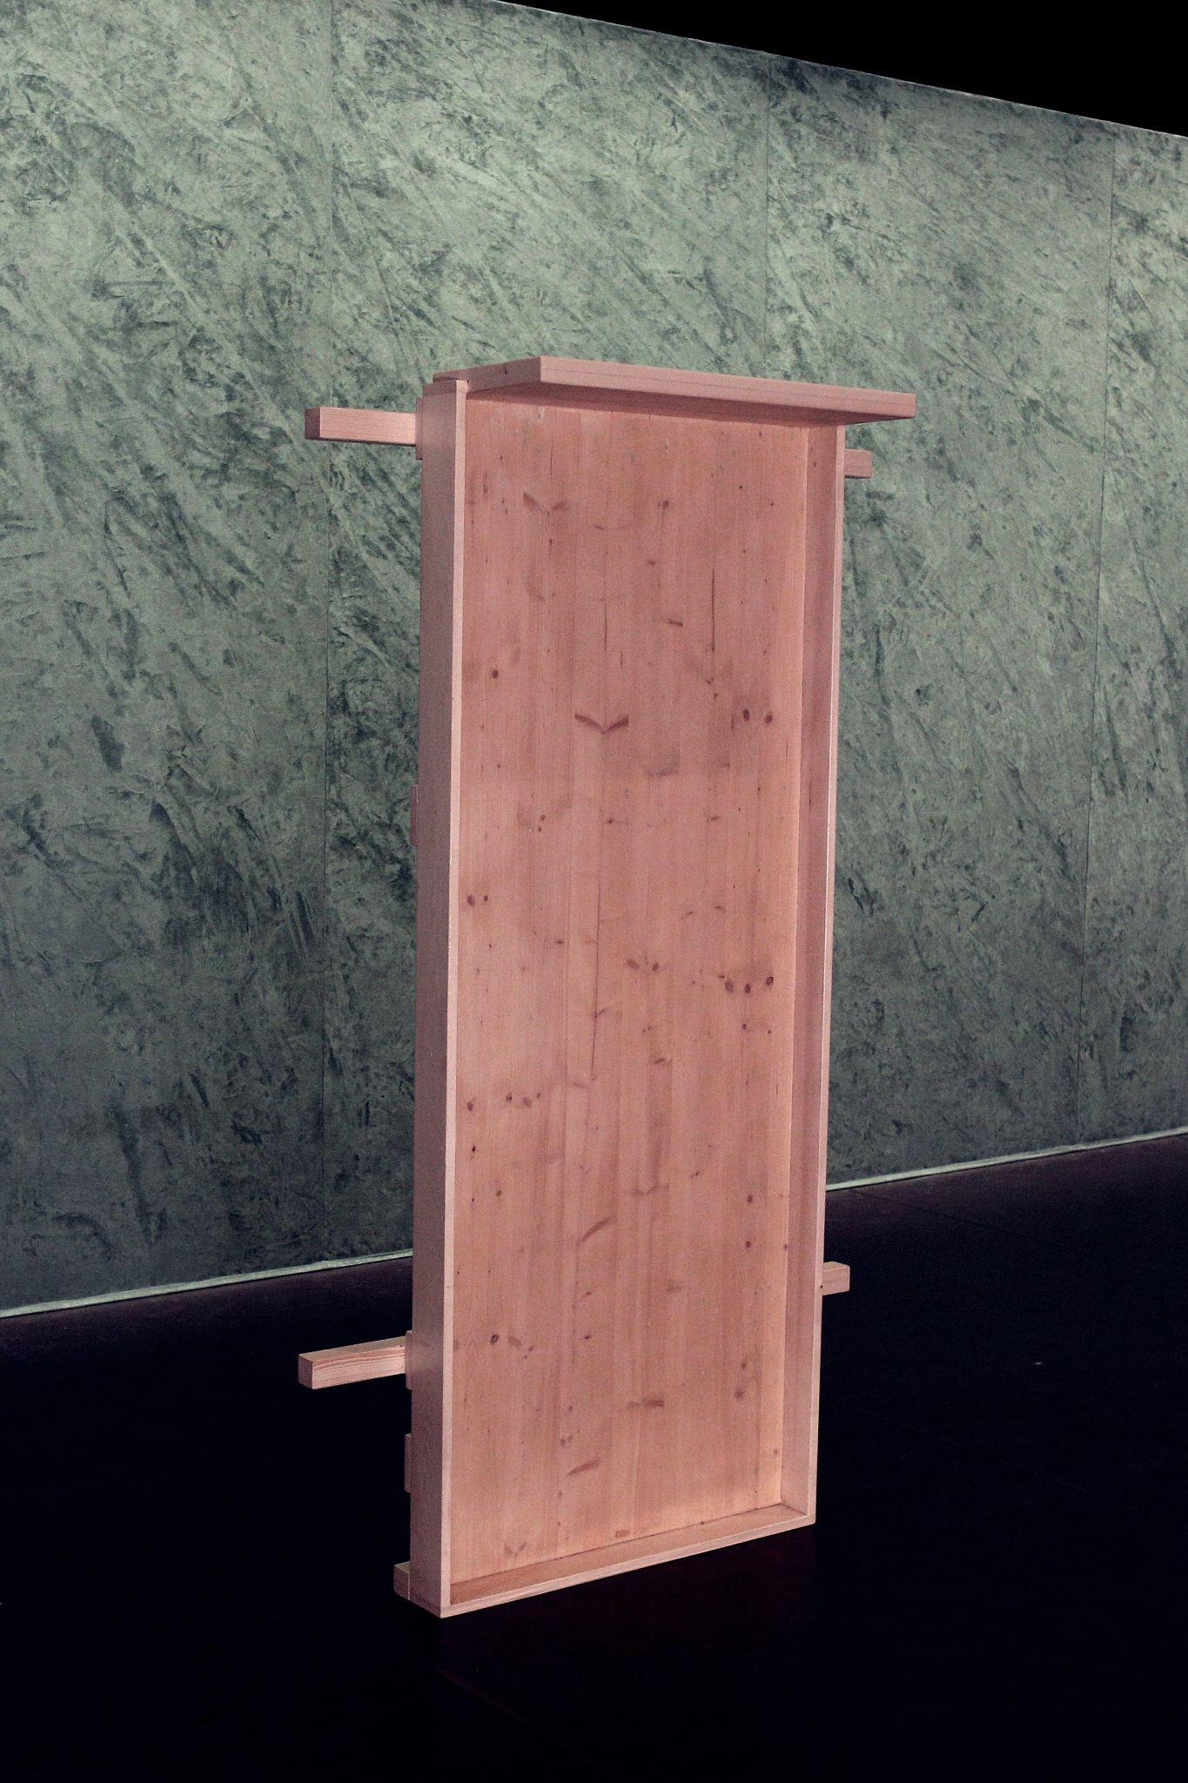

**Back wall:**

On the upstage we have a back wall.

Size: 3.3 meters h x 8-10 meters wide ( adjustable )

It is made out of a 25 x 25 mm metal frame (detachable) and one piece fabric screen.

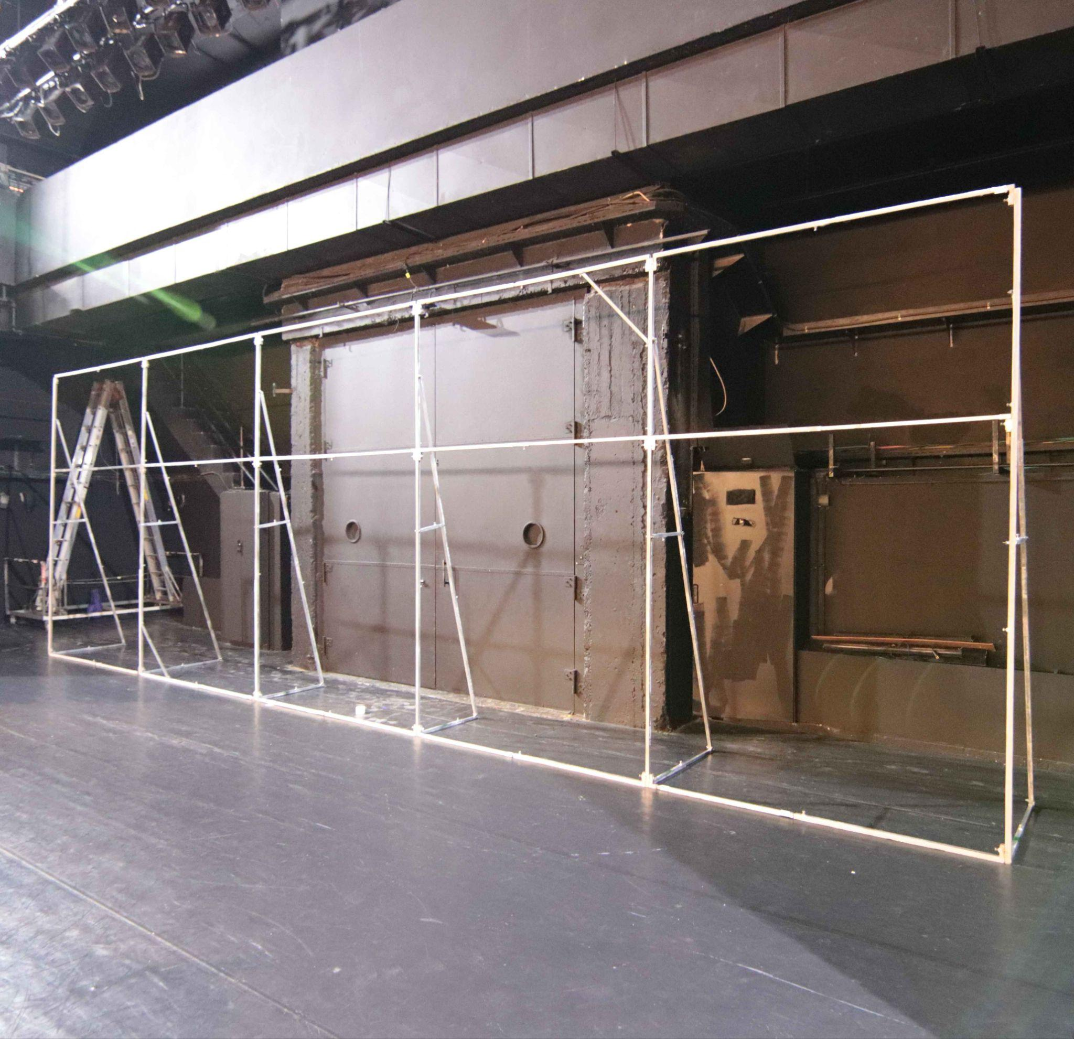

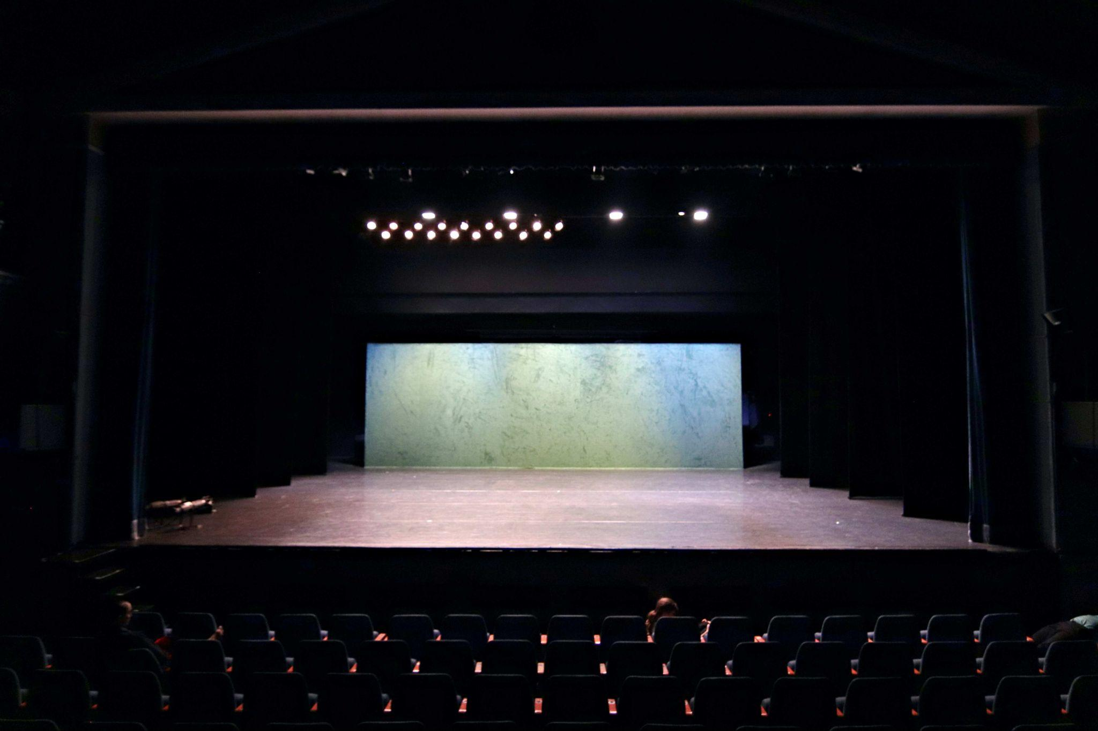

**Fly bars / Trusses**

The presenter will provide all necessary fly bars and or trusses to complete the attached sound and light plans, Minimum height 5.5 meters, optimum height 7 meters. Dead hung venues need to be discussed with the company.

**Masking**

The stage must be set up as german and italian black box:

Side wings, backdrop, borders and cover curtains for the side walls.

In case the presenter can’t supply this set up- alternative must be discussed with the company.

**FOH Position**

Operators could be positioned in a booth or behind the audience.

If possible, we prefer to position and lighting sound operators together in the house.

**Lighting instruments (presenter will provide):**

29 PC 1kW 310h RJ ( or equivalent )  
20 Fresnel 2000/2500W 329h RJ ( or equivalent )

45 profiles 613sx Juliat 28°\54° ( or equivalent )

10 profiles 714sx Juliat 15°\40° ( or equivalent )

10 ETC lustr 2 50º-25º ( or equivalent )

**Generic light plot:**

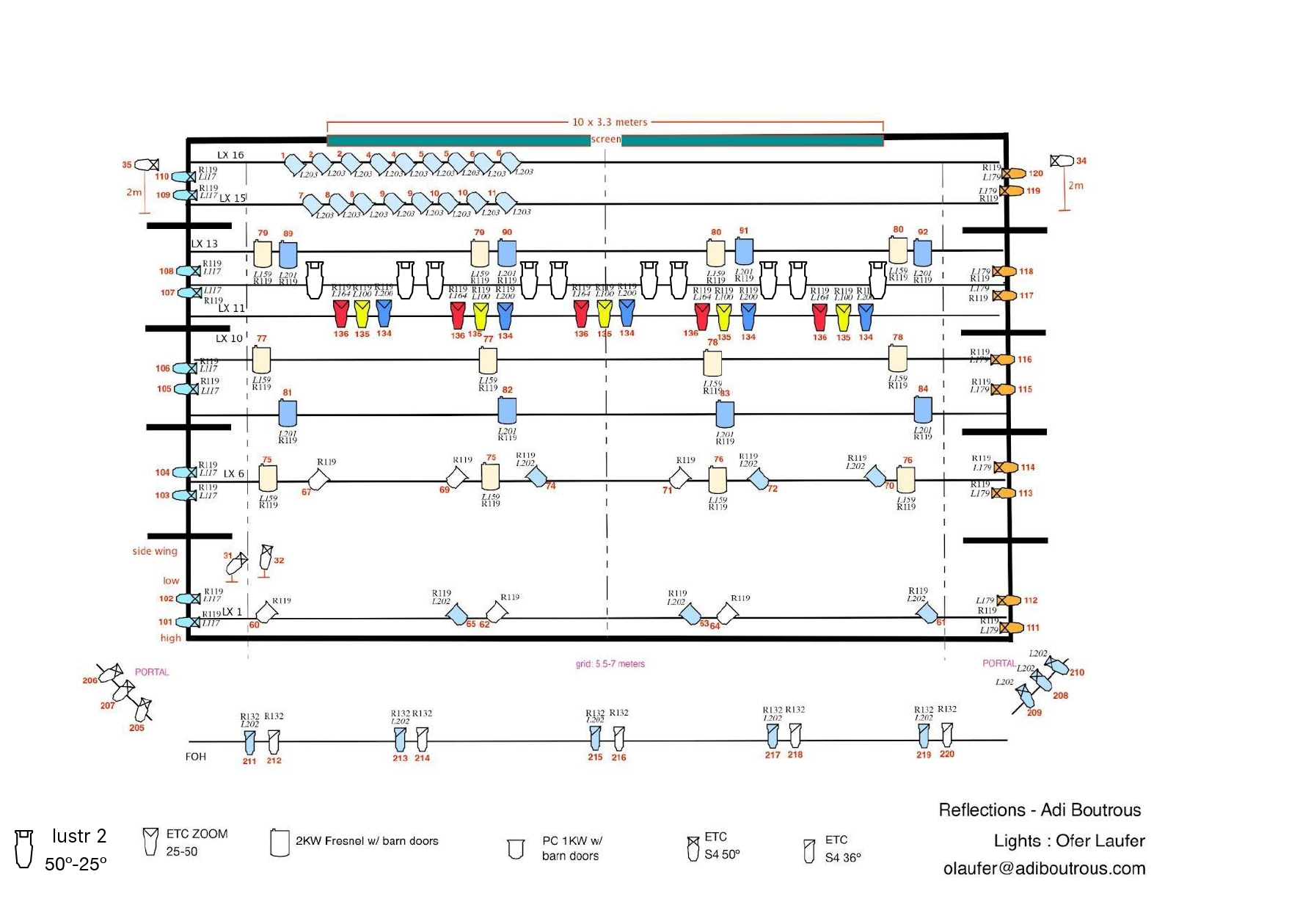

Presenter will provide all gels for light fixtures, necessary cables, connectors and accessories.

House lights must be on dimmer and accessible to our lighting operator because they are used

During the performance.

**For focusing**: An adequate mobile scaffolding or lift. If a mobile scaffold is not available or against house rules, an extra half a working day should be added to the setup schedule to facilitate focusing.

*G clamp or a type that is safe and fits the fly system of the venue.

**Sound**

High quality sound system That covers all audience seats equally and can provide 110

db spl of undistorted signal to the center of the venue, including subs, front fills,

delays, under balcony speakers etc.

Preferred systems: Meyersound, L-Acoustics.

4 15” speakers (Nexo Ps-15, L-Acoustics x12) hanged at four corners of the stage. If hanging is not possible - on stands, 2.5 meters high.

Array System is optional (for stage monitor).

Separate control + Delay Option on all speakers.

1 Digital console 24 channels minimum.

Preferred consoles: Midas Pro, Yamaha CL, Digico SD/Quantum, Avid s6

Qlab system with 4 outputs.

Wireless mic for rehearsal manager.

Tb mic (Sm-58).

All cables and wiring.

**Intercom**

Clearcom system with 5 stations (2 stage, 1 light, 1 sound, 1 show manager).

**Wardrobe**

The Company requires a wardrobe shop equipped with :

A washing machine.

A dryer.  
1 rolling wardrobe racks.

**Dressing rooms**

Sufficient dressing rooms for: 5 dancers, equipped with racks for hanging costumes, sufficient lighting, tables, chairs and mirrors. All dressing rooms must have direct access to, or be equipped with toilets, showers, sinks and hot and cold running water.

1 dressing room for the production & tech crew

**Heating**  
This is very important for the personal safety of the dancers. For rehearsals with dancers and performances, the stage and all other areas where dancers will be working (studios, dressing rooms, green room etc.) should be heated to 23C. Please note that during the technical setup and strike no such measures are necessary.

**Accommodation**

Sleeping arrangement: 1 double room, 5 to 7 single room, close to the venue

In case the presenter provides meals during the company stay, vegan options shall be available.

**Security**

Security must be provided at the venue and for Company’s equipment at all times.

---------------------------------------------------------------------------------------------------------------------

**This technical rider is part of the contract**

**It has to be signed by the technical director of the venue before signature of the contract**

**Name : Date**

**signature**